**Content Based Recommender System**

* A Content-Based Recommender works by the data that we take from the user, either explicitly (rating) or implicitly (clicking on a link).
* By the data we create a user profile, which is then used to suggest to the user, as the user provides more input or take more actions on the recommendation, the engine becomes more accurate.
* They build a **user profile** that captures the user's interest in various item attributes (like genre, tags, keywords).
* This user profile is then compared with new items to find those that are **most similar** to what the user already likes.
* Example: A user who watches romantic-comedy movies will be shown more such movies.

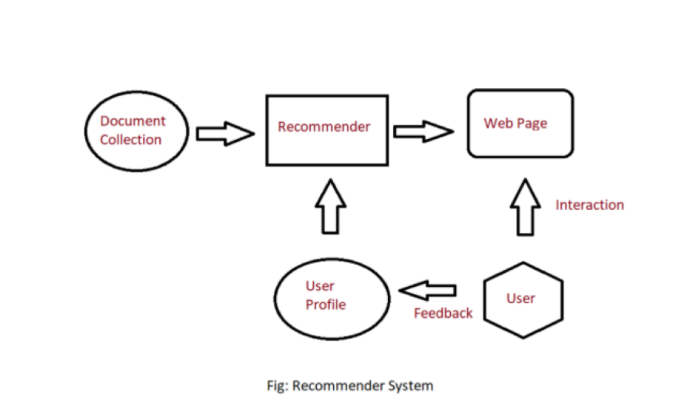

**What is User Feedback?**

* User feedback is the **input or behavior** that reflects how much a user likes or dislikes an item.
* It helps the system understand **user satisfaction** and **adjust the user profile** and **improve the recommendations** over time.

**Explicit Feedback**

1. **Direct User Input:** Users actively give their opinions by rating items (like giving stars) or writing reviews.
2. **Clear Preferences:** This feedback clearly shows how much a user likes or dislikes something.
3. **Requires Effort:** Since users have to take time to provide feedback, sometimes there isn’t much data available.

**Implicit Feedback**

1. **Behavior-Based Signals:** Feedback is collected by watching what users do, like which items they click, buy, or watch.
2. **Passive Collection:** Users don’t have to do anything extra; the system automatically records their actions.
3. **More Data but Less Clear:** There is usually lots of this data, but it can be harder to tell if a user really liked something or not.

**How Feedback is Integrated into Content-Based Systems**

**A. Updating the User Profile**

* The system maintains a dynamic profile for each user.
* When feedback is received, it updates the **importance (weight)** of certain features.
* **Positive feedback** increases the relevance of features (e.g., genre = comedy), while **negative feedback** decreases them.

**Example**:  
If a user gives a high rating to a comedy movie, the system increases the weight for the "comedy" feature in their profile. If they skip a horror movie, the "horror" feature gets reduced weight.

**B. Feature Vector Matching**

* Items and user profiles are stored as **feature vectors** (lists of numerical values).
* The system calculates the **similarity score** between the user vector and item vectors using algorithms like **cosine similarity**.
* Feedback updates these vectors.

**Example**:  
A user vector = [Action: 0.8, Comedy: 0.6, Drama: 0.1]  
A movie vector = [Action: 1.0, Comedy: 0.5, Drama: 0.0]  
The system computes similarity and ranks movies accordingly.

**C. Learning Algorithms**

To handle complex feedback, the system may use **machine learning** models.

* **Classification models** predict if a user will like an item.
* **Regression models** predict the exact rating.
* These models are **trained on past feedback data** to learn what features are important for different users.

**Example**:  
A model may learn that a user who likes “crime” and “mystery” genres is more likely to give 5-star ratings to such movies.

**Improving Accuracy Over Time: The Feedback Loop**

**A. Enhancing Personalization**

* With every new feedback, the system becomes **more personalized** to that specific user.
* The system understands user preferences, like “slow-paced romantic dramas” or “dark humor comedies.”

**Example**:  
Two users who like “drama” may get different suggestions because one prefers historical dramas and the other likes courtroom dramas.

**B. Adapting to Changing Preferences**

* A user's interests change over time.
* Feedback allows the system to **evolve** with the user.

**Example**:  
A user may have liked horror films 2 years ago, but now prefers documentaries. Ongoing feedback allows the system to recognize and adapt to this shift.

**C. Eliminating Irrelevant Content**

* Negative feedback helps the system understand what to avoid.
* The system **filters out** content that doesn’t match the user’s current taste.

**Example**:  
If a user consistently skips sci-fi movies, the system stops showing them.

**D. Cold Start Recovery for New Users**

* New users often have no history, making personalization difficult.
* Even **minimal feedback** (e.g., a few clicks or ratings) allows the system to build an initial profile quickly.

**Example**:  
If a user watches 2 documentaries in the first session, the system immediately starts recommending more factual content.

**Real-Life Example: Netflix**

Let’s say a user joins Netflix:

**Step 1: Early Interaction**

* Watches "Money Heist" and "Breaking Bad"

**Step 2: Feedback Given**

* Rates "Money Heist" 5 stars
* Skips "The Office" after 10 minutes

**Step 3: System Response**

* Increases preference weights for "Crime", "Thriller", "Spanish-language"
* Reduces interest in "Sitcom", "Comedy"

**Step 4: Updated Recommendations**

* Suggests shows like "Narcos", "Ozark", "Sacred Games"

This cycle repeats with every new watch or rating, and the recommendations become more accurate and satisfying over time.

**Hybrid Model for Enhanced Accuracy (Optional Add-on)**

Some systems combine content-based methods with collaborative filtering. This is called a **hybrid recommendation system**.

* Uses user feedback **plus** data from similar users.
* Helps overcome weaknesses of each method.

📝 **Example**:  
Spotify uses your listening history + similar listeners’ data to recommend new songs.